[Insert Picture of Your Facility]

Hazardous Materials Tabletop Exercises
  - Situation Manual
  - [Insert Date]
*[Insert Caveat]*
This Situation Manual (SitMan) provides exercise participants with all the necessary tools for their roles in the exercise. Some exercise material is intended for the exclusive use of exercise planners, facilitators, and evaluators, but players may view other materials that are necessary to their performance. All exercise participants may view the SitMan.

This page is intentionally left blank.

Exercise Agenda
Start Time | End Time | Activity
7:45 a.m. | 8:30 a.m. | Registration
8:30 a.m. | 8:45 a.m. | Welcome and Participant Briefing
8:45 a.m. | 9:45 a.m. | Module One: Intelligence and Information Sharing
9:45 a.m. | 9:55 a.m. | Break
9:55 a.m. | 10:55 a.m. | Module Two: Incident and Response
10:55 a.m. | 11:05 a.m. | Break
11:05 a.m. | 12:05 p.m. | Module Three: Recovery and Business Continuity
12:05 p.m. | 12:30 p.m. | Hot Wash
*All times are approximate

This page is intentionally left blank.

Exercise Overview
Exercise Name | Hazardous Materials Tabletop Exercise (TTX)
Exercise Dates | [Indicate the start and end dates of the exercise]
Scope | This exercise is a TTX planned for [insert exercise duration], at [insert exercise location]. Exercise play is limited to [insert exercise parameters].  This exercise was developed using materials created by the Cybersecurity and Infrastructure Security Agency (CISA) for a CISA Tabletop Exercise Package (CTEP).
Mission Area(s) | Prevention, Protection, Mitigation, Response, and Recovery [select Mission Areas]
Capabilities | Planning, Intelligence and Information Sharing; Operational Communications; Operational Coordination; Situational Assessment; Public Information and Warning; Public Health, Healthcare, and Emergency Medical Services (EMS); and Economic Recovery
Objectives | - Examine threat and incident information sharing, notification, and alert procedures between public and private partners, including public messaging protocols.  - Examine operational coordination using Incident Command System (ICS) concepts during a multi-agency, multi-jurisdictional response to an active threat.  - Examine public and private organization response procedures, interaction, and public relations collaboration during an active threat.  - Discuss recovery and business continuity plans in the wake of an active threat in an open-air venue.  - [Insert Additional Objectives]
Threat or Hazard | Truck ramming and hazardous material (HAZMAT) spill
Scenario | An interactive, discussion-based exercise focused on pre-incident information sharing, as well as response to and recovery from a vehicle ramming and HAZMAT spill.
Sponsor | [Insert the name of the sponsor organization, as well as any grant programs being utilized, if applicable]
Participating Organizations | [Insert a brief summary of the total number of participants and participations level (i.e., federal, state, local, tribal, non-governmental organization [NGOs], private sector, and / or international agencies)]. Consider including the full list of participating agencies in Appendix B. Delete Appendix B if not required].
Point of Contact | [Insert the name, title, agency, address, phone number, and email address of the primary exercise POC (e.g., exercise director or exercise sponsor).]

General Information

Exercise Objectives and Capabilities
The following exercise objectives in Table 1 describe the expected outcomes for the exercise. The objectives are linked to capabilities, which are the means to accomplish a mission, function, or objective based on the performance of related tasks, under specified conditions, to target levels of performance. The objectives and aligned capabilities are guided by senior leaders and selected by the Exercise Planning Team (EPT).
Exercise Objectives | Capability
Examine threat and incident information sharing, notification, and alert procedures between public and private partners, including public messaging protocols. | - Planning  - Operational Communication  - Operational Coordination  - Situational Assessment  - Intelligence and Information Sharing  - Public Information and Warning
Examine operational coordination using ICS concepts during a multi-agency, multi-jurisdictional response to an active threat. | - Planning  - Operational Communication  - Operational Coordination  - Public Health, Healthcare, and EMS
Examine public and private organization response procedures, interaction, and public relations collaboration during an active threat. | - Planning  - Public Information and Warning  - Operational Coordination
Discuss recovery and business continuity plans in the wake of an active threat in an open-air venue. | - Planning  - Public Information and Warning  - Economic Recovery
[Insert additional objectives as necessary] | - [Insert additional capabilities as necessary]
Table 1. Exercise Objectives and Associated Capabilities

Participant Roles and Responsibilities
The term participant encompasses many groups of people, not just those playing in the exercise. Groups of participants involved in the exercise, and their respective roles and responsibilities, are as follows:
- Players: Personnel who have an active role in discussing or performing their regular roles and responsibilities during the exercise. Players discuss or initiate actions in response to the simulated emergency.
- Observers: Do not directly participate in the exercise. However, they may support the development of player responses to the situation during the discussion by asking relevant questions or providing subject matter expertise.
- Facilitator: Provides situation updates and moderate discussions. They also provide additional information or resolve questions as required. Key EPT members also may assist with facilitation as subject matter experts (SMEs) during the exercise.
- Moderators: Moderators are responsible for admitting and signing in all participants to the virtual exercise, monitoring the chat area for questions and / or issues, and controlling participant audio.
- Evaluators: Are assigned to observe and document the discussion during the exercise, participate in data analysis, and assist with drafting the After-Action Report (AAR).

Exercise Structure
This TTX is comprised of three modules consisting of an international threat and incident followed by a domestic threat and incident. Players will participate in the following module elements:
- Module One: Intelligence and Information Sharing
- Module Two: Incident and Response
- Module Three: Recovery and Business Continuity
Each module begins with a multimedia update that summarizes key events occurring within that time period. After the updates, participants review the situation and engage in discussions of appropriate [insert mission area] issues.

Exercise Guidelines
- This exercise will be held in an open, no-fault environment wherein capabilities, plans, systems, and processes will be evaluated. Varying viewpoints, even disagreements, are expected.
- Respond to the scenario using your knowledge of current plans and capabilities (i.e., you may use only existing assets) and insights derived from your training.
- Decisions are not precedent setting and may not reflect your jurisdiction’s/ organization’s final position on a given issue. This exercise is an opportunity to discuss and present multiple options and possible solutions.
- Issue identification is not as valuable as suggestions and recommended actions that could improve [insert mission area] efforts. Problem-solving efforts should be the focus.
- The assumption is that the exercise scenario is plausible, and events occur as they are presented. All players will receive information at the same time.

Exercise Evaluation
Evaluation of the exercise is based on the exercise objectives and aligned core capabilities. Players will be asked to complete a participant feedback form. These documents, coupled with facilitator observations and evaluator notes, will be used to evaluate the exercise and then compiled into the AAR / Improvement Plan (IP).

Module One: Intelligence and Information Sharing

Scenario

[Insert Month, Day, Year]: [Time]
Based on recent attacks in the United States and internationally and increased chatter regarding similar attacks being called for, the Secretary of Homeland Security, in coordination with other federal entities, issues an “Elevated” Threat Alert through the National Terrorism Advisory System (NTAS), warning of a credible terrorist threat against the United States. There is no specific information at this time that would warrant the release of an “Imminent” Threat Alert.
The alert states that the threat is from domestic terrorist groups in the United States with ties to international terrorist organizations that are focused on [insert type of facility] or during a high-profile [insert type of event] events. The alert is to remain in place for three months, ending on [insert date + 3 months].
The [insert relevant state or local agency], using the [insert state / regional fusion center], has passed the alert on to its partners in the Commercial Facilities Sectors.
Additional information about the alert can be found in Appendix A.

Discussion Questions
- What do private sector stakeholders expect from the federal government and intelligence community at this time? How will you receive this information?
- How does your agency or organization triage the information you receive (formal reporting, hearsay, and social media)?
- What security recommendations, if any, are local, state, and federal law enforcement making to private sector stakeholders at this time?
- What established plans describe the required protective measures that need to be taken?
- What actions are local, state, and federal law enforcement agencies taking at this point?
- How would your agency or organization expect to receive information about a general threat?
- What steps does your organization take once they receive notice of a general threat?
- Does your agency or organization conduct any specific training based on threats?
- Are there additional notifications that need to be made outside of your organization?
- What kind of messaging would be released regarding general threats?
- How would questions from patrons and news organizations be handled?

Scenario Update

[Insert Month, Day, Year]: Time
Terrorist groups are very active over the past several months, garnering publicity by claiming responsibility for several overseas attacks. Officials reported that terrorists have launched two chemical attacks, killing or wounding up to 600 people, including children. Attackers are also suspected of using chlorine in attacks against opposition forces. There are growing concerns that terrorists would like to launch similar attacks in the United States.
Recently, three American HAZMAT trucking companies report cases of brake tampering that could result in a truck accident. Although the Federal Bureau of Investigation (FBI) does not have a specific threat at this time, they warn that in the past terrorists identified over-the-road tanker trucks and other mass conveyances of HAZMAT as potential targets.
The appropriate state homeland security agencies and / or local fusion centers have passed the alert on to their partners in the Transportation Sector.

Discussion Questions
            - What do private sector stakeholders expect from the federal government and intelligence community at this time? How will you receive this information?
            - What established plans describe the required protective measures that need to be taken?
            - Are there additional notifications that need to be made outside of your organization?
            - Who is responsible for engaging the public about the elevated threat level? How is this information communicated to the public?
            - Does your agency or organization conduct any specific training based on credible threats?
              - Does this training include emergency management or active assailant elements?
              - Does this training include ICS?
            - What security measures, if any, will be employed by private sector stakeholders?
            - How are private sector stakeholders coordinating with local, state, and federal law enforcement?
            - What actions are local, state, and federal law enforcement agencies taking at this point?
            - How does your agency or organization triage the information you receive (formal reporting, hearsay, and social media)?
            - Will the protective measures implemented for overseas venues differ from or impact the protective measures implemented in the United States?

Module Two: Incident and Response

Scenario

[Insert Month, Day, Year]: [Time]

[Insert Location]
It is a busy afternoon in [insert city, state] as the local baseball team prepares for their first weekend game of the season against their main rival. Nearby, the [insert name] Convention Center is setting up for a festival for the local basketball team, “Back to Winning Ways,” prepares to host their first playoff home game in eight years that evening.
As fans make their way from the parking garage to the west stadium gates, a large tanker truck picks up speed while headed down [insert street name] towards the [insert most popular entrance], careening into a crowd of fans on the sidewalk.
Multiple people are struck as everyone begins screaming and scrambling to get out of the way. The truck continues through the crowd before crashing into barricades and flipping over outside the stadium. The tanker immediately shows signs of damage and a potential chemical leak. The driver of the truck immediately jumps out and takes off on foot into the crowd.

Discussion Questions
- What protocols are in place at an event such as this to alert participants or local organizations of a vehicle ramming incident?
  - Who is responsible for sending out the alert or warning?
  - Would any additional organizations need to be engaged for an incident involving a tanker truck?
- Do any standard operating procedures (SOPs) include roles and responsibilities for event staff?
- What level of security / law enforcement would be on-site for this event?
  - How are they trained to respond to these types of incidents?
- What are crowd control and / or evacuation procedures for an event of this type?
  - Who is responsible for activating the evacuation procedures?
  - Is there a specified location for evacuees?
    - Would this location be changed in the event of inclement weather?
    - Are there secondary and tertiary rally points in case the primary point is a part of the incident or overwhelmed by evacuees?
  - Are event staff members trained in the procedures?
- Does your organization have a crowd control plan in place for an event such as this?
  - If so, are event staff members trained in the crowd control plan and procedures?
- Would there be any accountability taken of the staff working at the event and, if so, how is it accomplished?
- What command and control considerations would be taken at this point in the response?
- What is the role of private sector stakeholders in this command structure?
  - Are they trained on incident command procedures?
  - Is there cross-training?
- Would fire and EMS personnel be delayed in entering the scene to assist injured participants?
- At what point would the hospitals be alerted to the incident?
  - Who is responsible for alerting the hospitals?
- If the cell network is overwhelmed, does that affect you warning procedures?
  - Is there an alternate alert method?
- How quickly are messages being released to the public?
  - Who is responsible for this type of messaging?
  - How are they being released?
  - How are messages coordinated across the different agencies and organizations?
- What actions would your organization or facility take at this time in a similar scenario?
  - Whom would you contact?
  - How would you contact them?
- What actions are local, state, and federal law enforcement agencies taking at this point?
- What plans or procedures are in place to work with access and functional needs populations?
- How would your organization or business distribute messaging to your employees, patrons, and / or customers?
  - Would it be coordinated with any other businesses?

Scenario Update
Date: [Insert Date]
Time [Insert Incident + 15 Minutes]
[Insert Location]
Law enforcement located and arrested the driver of the vehicle. First responders confirmed several casualties, but do not have an exact count because they are unable to reach a number of individuals in the direct vicinity of the tanker truck because of leaking hazardous chemicals that produced signs of illness in from people nearby.
Local media, who were already on-site covering the game, are speaking to the public and have started live reporting. Families separated in the chaos are continuing to search for loved ones and are calling 911 to request information. Spectators are posting images and live streaming videos on social media. The convention center is inundated with questions regarding whether the festival will still take place.
Discussion Questions
            - What type of command structure would the responders establish upon being notified and arriving on scene of the second incident?
              - Who would be responsible?
            - What procedures are taken to stand up an emergency operations center (EOC)?
              - What is the role of the EOC in a situation such as this?
              - Would a multi-agency coordination (MAC) group be established?
            - How would law enforcement ensure the scene is secure?
              - What steps need to take place to ensure the area is cleared of all other potential threats?
              - What steps must be taken to engage the perpetrators?
            - How would resources be coordinated between the mass casualty incident (MCI) and HAZMAT incident?
              - Who is responsible for that coordination?
              - What other city / county resources will be used and how will that occur?
            - Would there be sufficient resources immediately available to begin stabilizing the incident scene?
              - If not, are there mutual aid agreements in place to assist?
            - Would an evacuation of fans impact patient care?
              - Do response plans include SOPs for patient care at an incident site?
            - What SOPs would law enforcement take when arriving / making entry into the incident scene?
            - What is the role of private sector stakeholders in this command structure?
              - Are they trained on incident command procedures?
              - Is there cross-training?
            - How would your organization or business distribute messaging to your employees, patrons, and / or customers?
              - Would it be coordinated with any other businesses?
              - Who is responsible for this?
            - What is being done at this time to reunite families separated during the incident and ensuing evacuation?
            - How does the ongoing HAZMAT incident impact public messaging and coordination?
              - Do generic, pre-scripted public messages exist that can be adapted to a particular incident?
            - How are the responders managing media access at the incident location, including media already present for the game?
            - How would the city or local agencies communicate incident information to surrounding businesses or organization?
              - How much information would be disseminated?
              - Who is responsible for distributing it?
            - At what point would federal authorities be contacted? Do your agencies cross-train on complex coordinated attack scenarios?

Module Three: Recovery and Business Continuity

Scenario

[Insert Incident + 2 Weeks]
There was a total of 12 fatalities resulting from the vehicle ramming with an additional 38 victims sustaining varying levels of injuries from the ramming and ensuing stampede. A further 8 victims, including several first responders, were hospitalized because of chlorine poisoning, but have since been released.
As the investigation continues, the community in [insert location] has started the recovery process and begun to reopen portions of the impacted area. Businesses and organizations are working on continuity plans, while members of the community try to recover from the loss of loved ones. Media is continuing to contact a variety of organizations looking for any additional information.

Discussion Questions
- What are short-term recovery procedures for your organization or business?
- Does your organization or business have a continuity of operations plan?
- Who makes the decision on when the area will be reopened?
  - How is that decision communicated to the public and the media?
- What would the financial impact be on your organization if it were closed because of such an incident?
- Would your business close because of these incidents even if it did not directly affect you?
- Are there contracts in place to assist in the cleanup of the area prior to reopening?
- Is social media being monitored to maintain awareness of information spreading that may not be accurate?
  - Who is responsible for this?
  - What procedures are in place to counter false information?
- What information, if any, would be passed on to the public in the wake of this event?
  - Who is responsible for this messaging?
    - Does messaging differ between a natural disaster and a terror incident?
    - How is messaging coordinated?
  - Is there a Public Information Officer (PIO) for media or social media inquiries?
  - Would people be directed to certain social media in the immediate aftermath to inform family / friends of their safety?
- Would family assistance or reunification centers be set up following the incidents?
  - If so, who is responsible for this?
  - What procedures are in place for this?
  - How are families made aware of where to go?
- Does your organization or business have mental health services available for your employees?
  - Is there an SOP for visitors that were impacted by incidents?
  - How would available services be communicated?
- What plans or procedures are in place to work with people with access and functional needs populations?
  - Who is responsible for that coordination?
  - What other city / county resources will be used and how will that occur?
- At what point would you consider the area and all associated organizations or businesses stabilized?
  - Who determines when it is safe for visitors to return to the area?
  - How is that communicated to the public?
- What state and federal constraints, particularly regarding recovery funds, impact the community’s ability to implement recovery plans?
- What assistance would your community or organization rely on, from both public and private stakeholders, to implement recovery plans?
- Does your community or organization have a plan for the management of donations or public memorials?
- What elements of recovery plans require the greatest amount of outside assistance?
- What efforts are being made to drive financial recovery?
- What would you consider to be the “new normal” for your organization and community?
- What recovery activities will continue after your community transitions from long-term recovery to the “new normal?”

Appendix A: Sample National Terrorism Advisory System Alert
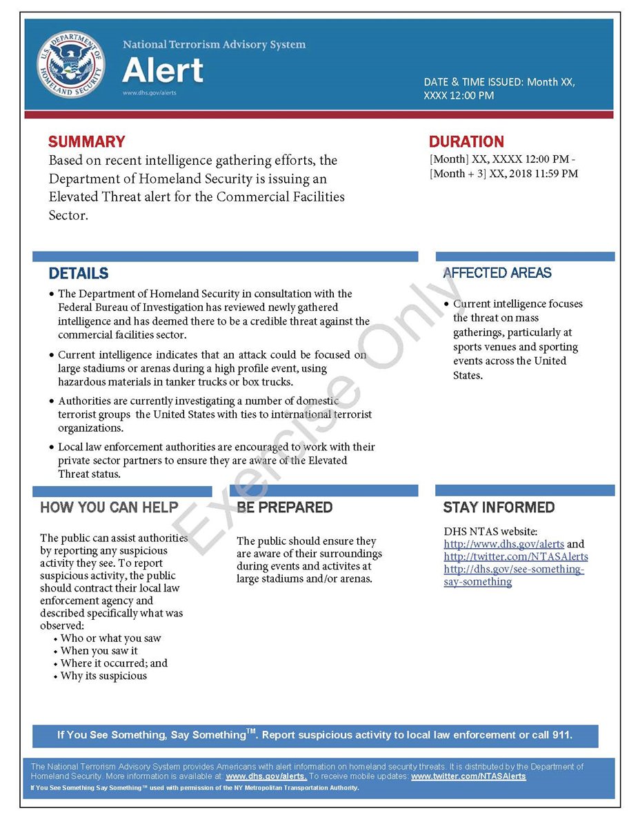
This page is intentionally left blank.

Appendix B: Exercise Participants
Participating Private Sector Organizations
[Insert private sector participants]

Participating Local Organizations
[Insert local participants]

Participating State Organizations
[Insert state participants]

Participating Federal Organizations
[Insert federal participants]

Other Participating Organizations
[Insert other participants]

This page was intentionally left blank.

Appendix C: Relevant Plans
[Insert excerpts from relevant plans, policies, or procedures to be tested during the exercise.]

This page is intentionally left blank.

Appendix D: Acronyms
Acronym | Term
AAR | After-Action Report
CISA | Cybersecurity and Infrastructure Security Agency
CTEP | CISA Tabletop Exercise Package
EMS | Emergency Medical Services
EOC | Emergency Operations Center
EPT | Exercise Planning Team
FBI | Federal Bureau of Investigation
HAZMAT | Hazardous Materials
ICS | Incident Command System
IP | Improvement Plan
MAC Group | Multi-Agency Coordination Group
MCI | Mass Casualty Incident
NGO | Non-Governmental Organization
NTAS | National Terrorism Advisory System
PIO | Public Information Officer
POC | Point of Contact
SitMan | Situation Manual
SME | Subject Matter Expert
SOP | Standard Operating Procedure
TTX | Tabletop Exercise

