Emergency Operations Plan
CISA OFFICE FOR BOMBING PREVENTION
BOMB THREAT MANAGEMENT ANNEX
A planning template

How to use this template:
This document is provided by CISA’s Office for Bombing Prevention to assist college and university officials charged with developing and implementing plans to manage bomb threat situations. It contains definitions, quick reference guides, planning considerations, and template language to simplify the task of developing safe and effective response procedures. The information provided is based on common principles for safety and best practices employed by similar organizations.
This document is not intended to provide comprehensive guidance on security matters, nor is it meant to replace advice by legal counsel, or effective response polices and plans. Furthermore, none of the information contained in this document supersedes any existing laws or directives.
Planner’s Note: This document can be used to guide the development of a Bomb Threat Management Annex to supplement an organization’s existing Emergency Operations Plan. Quick reference guides and sample language contained in this template can be inserted into the annex and customized to address unique characteristics of the organization and the surrounding community. To ensure successful implementation of actions outlined in the annex, the institution may want to consult with local law enforcement and other relevant entities agencies in the development and exercising of any Bomb Threat Management Annex.

Planner’s Note: This is the cover page of the institution’s Bomb Threat Management Annex to its Emergency Operations Plan. This page should contain the name of the plan and the date of its most recent revision. A suggested name for the plan is offered below. This page may also contain the college or university name and logo, as appropriate.

(Sample Title)
Emergency Operations Plan
BOMB THREAT MANAGEMENT ANNEX
TEMPLATE

Table of Contents
Planner’s Note: This table of contents lists recommended topics for inclusion in a Bomb Threat Management Annex. This page can be modified to reflect the actual contents of the annex and the format used by the organization in developing other Annexes to its Emergency Operations Plan.

ADMINISTRATIVE 1
Record of Changes 3
Forward 5
Purpose and Scope 5
Strategic Response Considerations 6
CHAPTER 1. BOMB THREATS AND EXPLOSIVES-RELATED EMERGENCIES 8
1.1. Definitions 8
1.2. Concept of Operations 9
1.3. Priority Actions for Bomb Threats 9
CHAPTER 2: RECEIVING BOMB THREATS 10
2.1. Phoned Threats 10
2.2. Written Threats 10
2.3. E-mailed Threat 11
2.4. Verbal Threat 11
2.5. Social Media Threats 11
2.6. Rumored Threats 12
2.7. Bomb Threat Call Checklist 13
CHAPTER 3. REPORTING AND NOTIFICATION OF BOMB THREATS 14
CHAPTER 4. RISK ASSESSMENT 14
4.1. Low Risk Threat - Lacks Realism 14
4.2. Medium Risk Threat - Increased Level of Realism 15
4.3. High Risk Threat - Specific and Realistic 15
CHAPTER 5. PROTECTIVE MEASURES 16
5.1. Visual Search 16
5.2. Bomb Threat Stand-Off Card 19
5.3. Evacuation 20
5.4. Reoccupation 21
CHAPTER 6. SUSPICIOUS MAIL 22
6.1. Indicators of Suspicious Mail 23
6.2. Priority Actions for Suspicious Mail 23
CHAPTER 7. COMMUNICATIONS 24
7.1. University Communications Policy 24
7.2. Emergency Communications 24
7.3. Media Communications 25
CHAPTER 8. THREAT MANAGEMENT TEAM 25
8.1. Law Enforcement Liaison Responsibilities (optional) 26
8.2. Search Team Leader Responsibilities 26
8.3. Evacuation Team Leader Responsibilities 26
CHAPTER 9. COORDINATION 27
9.1. Emergency Operations Center 27
CHAPTER 10. RESOURCES 28

ADMINISTRATIVE
Sample Language:
Planner’s Note: The administrative section can be used to introduce non-operational matters such as instructions for storing, maintaining, updating the Bomb Threat Management Annex. It can also describe the relationship of the annex to other plans and directives affecting the organization. Below is sample language that can be tailored to describe the administrative preferences of the organization. Additional administrative categories can be inserted.
“This annex is periodically reviewed and maintained by …
(insert name of the responsible department or office within the college or university”

“Concerns or questions regarding this annex should be directed to:
(insert name of position, i.e., Emergency Management Coordinator)
(insert Department or Office), i.e., Office of Emergency Preparedness
Phone: (xxx) xxx-xxxx”

“Related Documents:
This plan is an Annex to …
(insert the name of the overall plan, i.e., Emergency Operations Plan)
This plan is related to…
(insert other pertinent documents)”

”Authorities and References:
This annex has been developed in consideration of the university’s planning requirements outlined in OSHA’s Emergency Action Regulations, 29 CFR 1910.38; the Higher Education Opportunity Act (HEOA), Public Law 110-315; the U.S. Federal Family Education Right to Privacy Act (FERPA); and the Health Insurance Portability and Accountability Act of 1996 (HIPAA).”
“Compatibility with other Emergency Operations Plans:
This annex was developed in consultation with local public safety and law enforcement agencies. It can be used in conjunction with other emergency operation plans including local, regional, and state plans and complies with county and state authorities pertaining to emergency management, operations, and response.”

This page intentionally left blank

Record of Changes
Planner’s Note: This section can be used to record details regarding revisions to the annex. Below is a sample chart that lists dates of revisions, page numbers, contents of the changes, and the responsible parties. This chart can be tailored to allow the organization capture additional important information.

Sample Chart:

Date of Revision | Revised Pages & Content | Revisor

This page intentionally left blank

Forward
Planner’s Note: This section can be modified to express the organization’s message of commitment to preparedness. Sample language is offered below.
Sample Language
“The university is committed to providing a safe and secure environment for all students, staff, and visitors. During emergency or disaster situations, the overall priorities of the university are the protection of lives, property, community, and environment, the assurance of continuity of operations, and the restoration of essential and normal activities as soon as possible. In support of this commitment, the university adopts a comprehensive approach to preparedness through the development of emergency operations plans that address a full spectrum of emergencies. This annex provides guidance to effectively manage the specific challenge of bomb threats and suspicious items that may pose explosive hazards. The name of this annex is the Bomb Threat Management Plan, hereafter referred to in this document as the annex.”

Purpose and Scope
Planner’s Note: Emergency management plans are developed to guide the actions of the university and inform the effective management of emergencies in which normal operations are disrupted and special measures must be taken. This section can be modified to express the purpose and scope of the Bomb Threat Management Annex. Sample language is offered below.
Sample language
“The purpose of the Bomb Threat Management Annex is to ensure procedures are in place to protect students, staff, visitors, and school property in the event of a bomb threat. This plan outlines the organizational structure, key roles and responsibilities, and general procedures to follow during and immediately after receipt of a bomb threat affecting the school. The plan acknowledges the roles and responsibilities of other entities, such as public safety and law enforcement agencies regarding bombing-related matters that occur on university property. It includes cooperation and coordination with such entities but is not intended to dictate their specific actions.”

Planner’s Note: Due to the hazardous nature of explosive devices, every bomb threat must be taken seriously to ensure the safety of all university students, staff, and visitors. Instinctive responses to bomb threats often include automatic and complete evacuation. Unfortunately, such predictable responses can contribute to the use of false or hoax bomb threats for nefarious purposes including extortion, disruption, or to simply make people feel unsafe. An understanding of the financial, operational, and psychological impacts of false bomb threats is important to the university’s development of a deliberate response strategy that maximizes safety, and resiliency, and minimizes disruption.
In addition to creating panic and chaos, hoax bomb threats can be used to divert attention from simultaneous crimes or other activities for the purpose of challenging the capacity of campus security and law enforcement resources. With even more nefarious intent, hoaxes can be used to study the methods by which emergency responders act, possibly as a means of predicting their behavior during future incidents. Finally, these false threats can be used to draw evacuated people away from safe settings into areas of grave danger such as near actual explosive devices or gunfire.
Recognizing that university response actions can exacerbate certain situations, every bomb threat must be individually assessed to define the context, identify potential risks, and implement appropriate response actions. Local authorities and federal guidance are useful resources in developing effective bomb threat management strategies. Sound plans and procedures for managing bomb threat situations can directly assist the university in protecting lives and property, as well as its mission and reputation.
The following chapters provide definitions, recommended actions, and quick reference guides for safe and effective response to bomb threats. Much of the material is suitable for direct insertion into a Bomb Threat Management Annex. The information can also be modified, as appropriate, to address unique conditions, procedures, or nomenclature used by the university.

Strategic Response Considerations
Due to the hazardous nature of explosive devices, every bomb threat must be taken seriously to ensure the safety of all university students, staff, and visitors. Instinctive responses to bomb threats often include automatic and complete evacuation. Unfortunately, such predictable responses can contribute to the use of false or hoax bomb threats for nefarious purposes including extortion, disruption, or to simply make people feel unsafe. A understanding of the financial, operational, and psychological impacts of false bomb threats is important to the university’s development of a deliberate response strategy that maximizes safety, and resiliency, and minimizes disruption.
In addition to creating panic and chaos, hoax bomb threats can be used to divert attention from simultaneous crimes or other activities for the purpose of challenging the capacity of campus security and law enforcement resources. With even more nefarious intent, hoaxes can be used to study the methods by which emergency responders act, possibly as a means of predicting their behavior during future incidents. Finally, these false threats can be used to draw evacuated people away from safe settings into areas of grave danger such as near actual explosive devices or gunfire.
Recognizing that university response actions can exacerbate certain situations, every bomb threat must be individually assessed to define the context, identify potential risks, and implement appropriate response actions. Local authorities and federal guidance are useful resources in developing effective bomb threat management strategies. Sound plans and procedures for managing bomb threat situations can directly assist the university in protecting lives and property, as well as its mission and reputation.

CHAPTER 1. BOMB THREATS AND EXPLOSIVES-RELATED EMERGENCIES

Definitions
- Bomb: A device capable of producing an explosion. Also known as an improvised explosive device (IED), its explosive effects can cause death or injuries. IEDs can vary in size and composition making them easy to conceal and transport. The abbreviation “IED” or the term “device” is utilized throughout this plan to replace the term “bomb” when appropriate.
- Bomb Threat: A communication about the possible presence of an explosive device. Threats can be conveyed by various means including, but not limited to verbal communication in person or by telephone, text, social networking sites, and hand-written. Knowingly making a false bomb threat is illegal and subject to various levels of prosecution.
- Unattended Item: Anything (e.g., bag, package, vehicle, etc.) of unknown origin and content where there are no obvious signs of being suspicious (i.e., no strange odor, wires, or signs of the item being altered). Facility search, lock-down, or evacuation is not necessary for unattended items unless the item is determined to be suspicious. A law enforcement response is not required to adjudicate unattended items.
- Suspicious Item: Anything (e.g., package, vehicle) reasonably believed to contain explosives, an IED, or other hazardous items that require a bomb technician to further evaluate. Potential indicators that an item is suspicious include threats, placement, and proximity of the item to people and valuable assets. Other indicators include unexplainable wires or electronics, other visible bomb-like components, unusual sounds, vapors, mists, or odors. Generally anything that is Hidden, Obviously suspicious, and not Typical (HOT) should be deemed suspicious.
- Bomb Threat Management Team: The individuals whose roles and responsibilities must be identified in the BTM plan. These members are the:
- Receiving Party. The person who receives the threat.
- Decision Maker. The person who oversees the activation of the plan and makes final decisions as to how to manage the incident.
- Law Enforcement Liaison. The person who is the communication bridge between the Decision Maker and any law enforcement response.
- Search Team Leader. The person who oversees the search team.
- Search Team. The individuals who conduct searches related to the threat as directed by the Decision Maker.
- Evacuation Team Leader. The person who oversees the evacuation team.
- Evacuation Team. The individuals who lead people to assembly areas.
- Evacuees. The individuals being evacuated (e.g., employees, customers, visitors, etc.)
- Runners. The individuals who transport equipment or messages between teams, leaders, and the Decision Maker.
- Bomb Technician: A public safety officer who is specially trained and certified to diagnose and render safe explosive threats.

Concept of Operations
Critical functions outlined in this plan are consistent with the National Incident Management System (NIMS). NIMS is the common framework used throughout the United States to facilitate response coordination between all levels of government with public, private, and nongovernmental organizations. The university’s base plan for emergency operations provides a flexible framework for organization that incorporates the Incident Command System (ICS), and seamlessly accommodates resources and assistance from outside entities, as warranted. It is designed to be scalable and implemented in part or in full, based on the needs of the situation. It is intended to provide a smooth transition through all phases of response and recovery and restoration of normal services. The Bomb Threat Management plan comports with the base plan and serves to highlight the priority actions and requirements to effectively address hazards posed by explosives-related incidents.

Priority Actions for Bomb Threats
- Contact local law enforcement
- Assess the threat to determine its level of risk.
- If warranted, mobilize search team(s).
- Communicate with personnel about the bomb threat condition.
- Limit access to buildings or other areas at risk.
- Determine and execute appropriate protective actions:
- Search
- Evacuation: partial or full

CHAPTER 2: RECEIVING BOMB THREATS
Bomb threats are conveyed by various means, including but not limited to telephonic, electronic, (e-mail or social media), in writing, in person, or by rumor.

Phoned Threats
- A bomb threat delivered by telephone can contain important details that reveal the identity of the caller. Therefore, when receiving a bomb threat by telephone, pay careful attention to the words being used, the sound of the voice and any background noises or other pertinent details.
- If a phoned threat is received, the following actions are recommended:
- If possible, start a recording device.
- If possible, note the caller identification number.
- If possible, signal another person to assist you in monitoring the conversation.
- Write down the exact wording used in the threat as well as any other details about the call.
- Immediately review the Bomb Threat Card Checklist and answer the questions in as much detail as possible.
- Promptly report the threat in accordance with procedures outlined by the facility. For more information, refer to Chapter 3.
- Be available for interview.
Planner’s Note: Variations in telecommunications technologies and policies result in different procedures to trap and trace incoming calls. Therefore, it is recommended that university planners consult their institution’s local phone carrier for guidance on legal trap and trace capabilities.

Written Threats
- If a written or printed bomb threat is received or discovered, the following actions are recommended:
    - Refrain from handling the item as much as possible.
    - Preserve the item that contains the threat.
- Promptly report the threat in accordance with procedures outlined by the facility. For more information refer to Chapter 3.
    - Note the date, time, and location you discovered the item.
    - If possible, photograph the item and any surrounding objects or materials.
    - Write down a description of the situation or conditions surrounding the discovery, and any other people who may have discovered the threat.
    - Be available for interview.

E-mailed Threat
- If an e-mailed threat is received, the following actions are recommended:
- Promptly report the threat in accordance with procedures outlined by the facility. For more information, refer to Chapter 3.
    - Leave the e-mail open until assistance arrives.
    - Print, photograph, or copy the message. Include the header of the e-mail.
    - Digitally SAVE the e-mail if possible.
    - Be available for interview.

Verbal Threat
- If a verbal threat regarding a bomb is received, the following actions are recommended:
    - Project calmness; move and speak slowly, quietly, and confidently.
- When safe to do so, report the threat in accordance with procedures outlined by the facility. For more information refer to Section 3.
    - Note the description of the person who made the threat. (Refer to the applicable section of the Bomb Threat Card)
- Name, if known.
- Body type, height, and weight.
- Sex.
- Hair, eye, and skin color.
- Type and color of clothing.
- Tattoos and any distinguishing features.
- Any items in the individual’s possession.
    - Make note of any surveillance cameras in the path of suspect’s route of travel.
    - Make note of the individual’s mode of travel and the last place they were seen.
    - Document the exact wording of the threat.
    - Be available for interview.

Social Media Threats
- If a bomb threat made through social media, the following actions are recommended:
    - Note the name of the person making the threat and the application that was used to make it.
    - Record the exact wording of the threat as it was posted.
    - If possible, take a screen shot and preserve the image.
    - Promptly report the threat in accordance with procedures outlined by the facility. For more information, refer to Chapter 3.
    - Be available for interview.

Rumored Threats
- If people are overheard talking about a bomb threat or planned attack, the following actions are recommended:
- Write down exactly what you heard.
- Record information about the identity of the people being overheard.
- If safe to do so, photograph the individuals.
- Note the place and time.
- Promptly report the threat in accordance with procedures outlined in by the facility. For more information, refer to Chapter 3,
- Be available for interview.

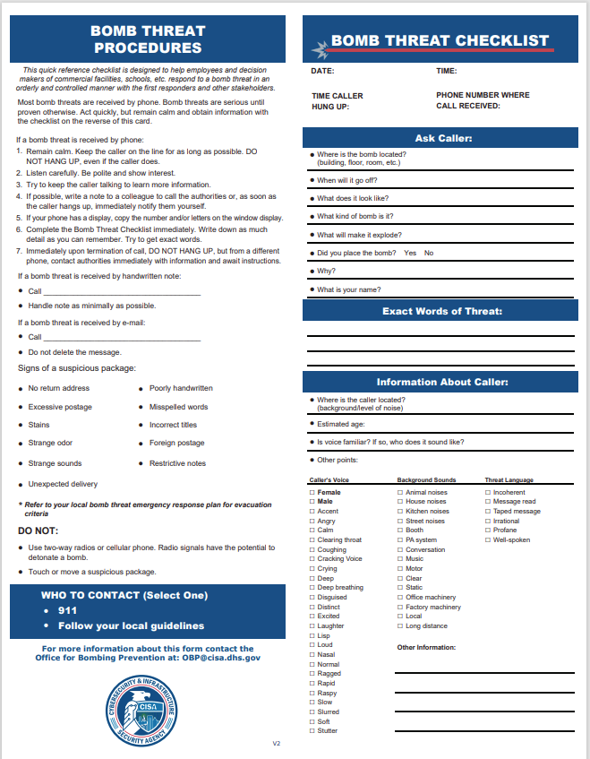
Bomb Threat Call Checklist

CHAPTER 3. REPORTING AND NOTIFICATION OF BOMB THREATS
Planner’s Note: Every bomb threat is unique and should be reported in accordance with procedures outlined by the facility or environment in which it occurs. Many institutions have resident security or police services with well-advertised phone numbers for reporting emergencies and suspicious activity.
Additionally, heightened concern nationwide regarding campus security, combined with the technical abilities of cell phones and other personal devices has led to the widespread use of emergency messaging applications to notify students, faculty, and staff of emergencies in their vicinity. Some of these apps can also connect individuals directly with designated emergency numbers to report suspicious activity or provide tip information. Other features include the ability to send details, such as photographs and GPS coordinates while reporting suspicious activity.
This section can be used to insert the university’s procedures for reporting bomb threats, including contact information and instructions for using emergency notification systems or applications.

CHAPTER 4. RISK ASSESSMENT
Planner’s Note: All bomb threats should be taken seriously. In every case, the university’s response should be based on an assessment of the risk posed by the current threat. This section can be used to insert the university’s procedures for assessing the risk posed by each bomb threat. Sample language is offered and can be modified to accommodate the organization’s policies and nomenclature.
Sample Language
“The process of assessing each bomb threat individually is intended to guide leadership decisions about appropriate evacuation, searches, and other possible courses of action.
To accurately assess each situation, the recipient of a bomb threat should personally describe the details of what occurred directly to the Site Decision Maker before being asked any questions. This practice ensures the recipient is speaking from personal memory without any influence of outside suggestions.
The Site Decision Maker will evaluate the description of the threat in the context of the three levels of risk outlined below. In addition, the totality of the circumstances should be considered. These additional factors may include prior acts or current events against the university or other universities, accessibility of the site, danger in evacuating certain areas, and advice of public safety officials.”

Low Risk Threat - Lacks Realism
Threat poses minimum risk to the victim and public safety. Probable motive is disruption.
- Is the threat vague or indirect?
- Is information contained within the threat inconsistent or implausible?
- Is the identity of the caller known as someone who frequently makes threats?
- Was the threat discovered instead of delivered, e.g., a threat written on a wall?

Medium Risk Threat - Increased Level of Realism
Threat that could be carried out, although it may not appear realistic.
- Is the threat direct and feasible?
- Does wording in the threat suggest the perpetrator has given some thought about how the act will be carried out?
- Does the threat include indications of a possible place and time?
- Is there an indication the perpetrator has details regarding the availability of components needed to construct an improvised explosive device?
- Does the caller emphasize the threat, e.g., “I’m serious!” or “I really mean this!”?

High Risk Threat - Specific and Realistic
Threat appears to pose immediate danger to life and safety.
- Is the threat direct, specific, and realistic?
- Are names of possible victims included?
- Are specific times or locations included in the threat?
- Does the perpetrator provide their identity?
- Does the threat suggest that steps have been taken to carry out the threat such as experience with explosives or surveillance of intended victims?

CHAPTER 5. PROTECTIVE MEASURES

Visual Search
Planner’s Note: Based on the assessment of the threat described in Chapter 4, certain protective measures may be appropriate, such as visual searches of specific buildings and command post locations as well as evacuation routes and rally points. In preparation for this possibility, search team members should be trained to use procedures that ensure the safety and effectiveness of visual search activities.
This section can be used to insert the university’s procedures for conducting search activities. Sample language and guidelines are offered and can be modified to accommodate the organization’s policies and nomenclature.
Sample Language
“If a decision to search is approved by the Site Decision Maker, search teams will be assembled and deployed with instructions regarding actions to take upon discovery of a suspicious item or upon completion of their search.”
General search guidelines include:
- Start on the outside of the building and work inward.
- When inside, start at the bottom and work upward.
- Search personnel should always work towards one another.
- Listen for background noises.
- Clear evacuation routes and assembly areas.
- Understand the difference between “Unattended” and “Suspicious” items.
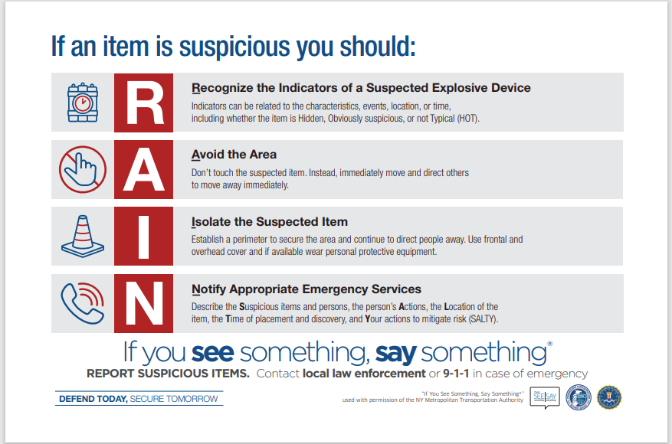
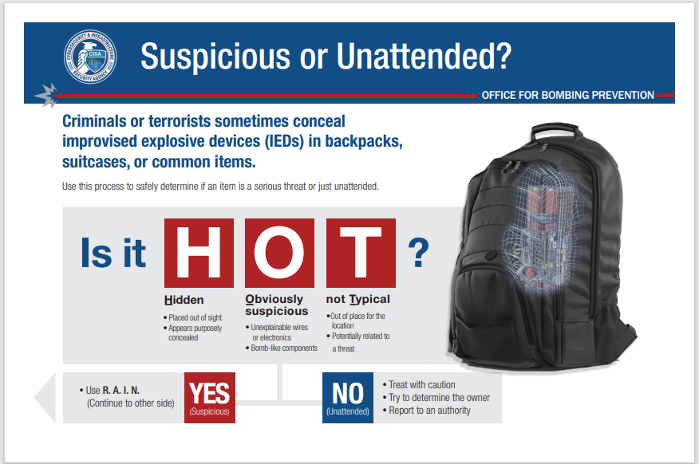

In the event a suspicious item is found:
- Note the location of the item.
- Do not touch, open, or move the item.
- Do not cover or enclose the item to minimize effects of an explosion.
- If possible, mark a nearby door or approaching stairwell with tape or other visible signal to guide bomb technicians to the item.
- Notify other search personnel to safely leave the area and depart with them.
- Do not allow any faculty, staff, students, or visitors access to, or near, the proximity of a suspicious item.
- Avoid using cellular telephones near the suspicious item.
- Do not pull fire alarms to evacuate any buildings, unless specifically directed to do so by emergency personnel.
- Immediately report the discovery to the Site Decision Maker.
Based on this discovery the Site Decision Maker should:
- Evacuate personnel from the affected area.
- Consider “shelter in place” option for those outside the affected area.
- Secure the area.
- Notify search teams of the discovery for their awareness.
- Ensure emergency responders are briefed.
It is important to note that multiple explosive devices may be present. As such, search operations should not be terminated upon the discovery of a single suspicious item. Rather, search operations should be conducted to their logical completion.

Bomb Threat Stand-Off Card
The decision to evacuate or shelter in place should be based on the assessment of the current threat. A guide for determining safe distances for sheltering in place or evacuation is the Bomb Threat Stand-Off Card DHS-DOJ Bomb Threat Stand-off Card.

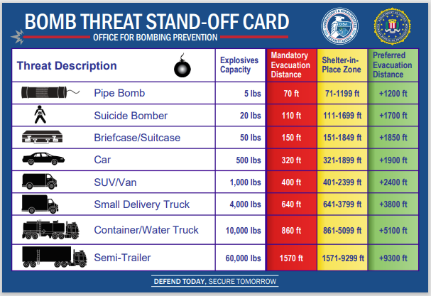
Shelter in Place
If sheltering in place is deemed appropriate by the Site Decision Maker or other authority, the following actions are recommended:
Planner’s Note: Sheltering in place is a temporary strategy designed for use when it is safer for people to remain inside their current location rather than evacuate to the outside. Based on the assessment of the threat described in Chapter 4, certain protective measures may be appropriate, such as visual searches of specific buildings and command post locations as well as evacuation routes and rally points. In preparation for this possibility, search team members should be trained to use procedures that ensure the safety and effectiveness of visual search activities.
This section can be used to insert the university’s procedures for conducting search activities. Sample language and guidelines are offered and can be modified to accommodate the organization’s policies and nomenclature.
- Remain calm.
- Suspend all activities.
- Move all people to interior classrooms, offices, hallways, or designated shelter-in-place locations for the building.
- Do not use elevators.
- Stay in the shelter area until otherwise instructed by the Site Decision Maker or other appropriate authorities.

Evacuation
If evacuation is initiated, the following actions are recommended:
Planner’s Note: Evacuation in response to a bomb threat is the movement of personnel away from an area that contains an imminent threat to life. The area to be evacuated could be limited to a single building or could involve an entire campus. The decision to evacuate should be based on the risk assessment process outlined in Chapter 4. In preparation for evacuation contingencies, primary and alternative evacuation routes and assembly areas should be established.

- Select evacuation routes and assembly areas that are not in the vicinity of the suspicious item. Consult the Stand Off Card for guidance regarding safe distances for shelter in place and evacuation measures based on the size of the threat device.
- Search and clear the selected evacuation routes of any suspicious items.
  - If a suspicious item is discovered on the evacuation route, retreat from the area and immediately select a safer route.
- Notify police/fire/EMS of evacuation route and request assistance.
- Advise evacuees to remove all personal carry items, e.g., purses and backpacks.
- Do not alter the environment of the by turning off lights or air, or by closing doors, etc.
- Account for all personnel.

Reoccupation
Planner’s Note: Re-entry to evacuated areas must not be permitted until the search team and/or law enforcement authorities notify the Site Decision Maker that no hazardous devices have been found.
Thereafter, reoccupation should be conducted in a safe and orderly manner. The process for reoccupation of certain facilities may require a phased approach in which essential personnel re-enter the building first to ensure there are safe conditions and sufficient services for the general population to return.

When it is permissible to reoccupy the building, it is recommended that staff and students visually inspect their immediate work areas/classrooms before resuming activities and promptly report anything new or suspicious.

CHAPTER 6. SUSPICIOUS MAIL
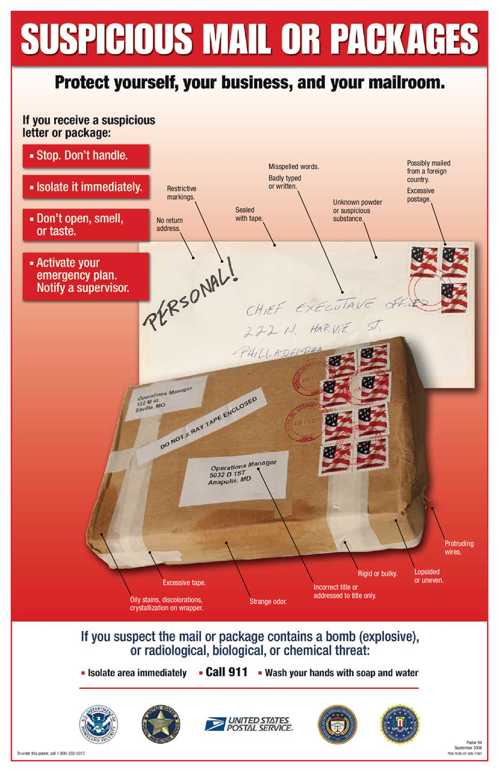

Indicators of Suspicious Mail
Improvised explosive devices can arrive at the university through the mail disguised as a letter, books, and packages of various sizes and shapes. The following may be indicators of suspicious mail:
- Letter texture may feel ridged, look uneven or lopsided, or feel bulkier than normal.
- Excessive amounts of postage may be present—often far more than needed.
- The sender is unknown or there is no return address.
- Handwritten notes appear, such as, “rush,” “personal,” or “private;”
- The addressee normally does not receive mail at the office.
- Cut or pasted homemade labels are used for lettering.
- The letter or package may emit an odor, have oily stains, or appear to have been disassembled and re-glued.
- Several combinations of tape are used to secure the package.
- Contents of the parcel sound like liquid or nails.
- The package or letter shows a city or state in the postmark that does not match the return address.
- The package or letter is marked Foreign Mail, Air Mail, or Special Delivery.
- The package has protruding wires.
- The package or letter has incorrect titles, or a title but no name.
- Misspellings of common words are present.

Priority Actions for Suspicious Mail
If suspicious mail is received, the following actions are recommended:
- DO NOT open the package.
- Immediately notify University Police or dial 911.
- Have everyone vacate the immediate area and close any doors, or cordon the area, to prevent others from entering.
- List all individuals who handled the suspicious letter or package.

CHAPTER 7. COMMUNICATIONS

University Communications Policy
Planner’s Note: This section can be used to insert university policies and procedures for communicating with affected individuals and the media during emergencies. Sample language and guidelines are offered and can be modified to accommodate the organization’s policies and nomenclature.
Sample Language:
“The university is committed to resolving all emergencies and protecting the safety and well-being, as well as the privacy and dignity of all persons involved. It is the strict policy of the university to defer such communications to an authorized spokesperson who can communicate both effectively and within the constraints of the law.”

Emergency Communications
Planner’s Note: If the university maintains an emergency notification system, this section can be used to insert policies and procedures for communicating with affected individuals during emergencies. In preparation for issuing campus-wide communications during bomb threats, pre-scripted and approved messages can be developed to reduce confusion and save valuable time.
Sample language and guidelines are offered and can be modified to accommodate the organization’s policies and nomenclature.
Sample Language:
“If deemed appropriate, per the university’s Emergency Notification System Use Policy, to make an emergency announcement, (insert the name or position of) the designated ENS user will be responsible for composing and issuing the message, with input from the designated communications coordinator as time permits.”

Media Communications
Planner’s Note: Emergencies on one campus can have repercussions that affect other campuses and the reputation of the university on a national and international stage. Therefore, all disseminations of information to the media on behalf of the university should be coordinated through designated personnel and processes. A communications coordinator can be designated to interface with university executives for public affairs, General Counsel, and others, as appropriate for the execution of sound media strategies.
This section can be used to list the names and positions of designated individuals with authority and responsibilities regarding information dissemination to media outlets on behalf of the university.

CHAPTER 8. THREAT MANAGEMENT TEAM
Planner’s Note: An emergency management framework is outlined in the university’s base plan for emergency operations. This framework provides organization and procedures to support the university’s response to most emergency situations.
This section can be used to list a description of key leadership roles and responsibilities that may be important to the successful resolution of challenges posed by bomb threats and explosives-related emergencies. Sample language is offered and can be modified to accommodate the organization’s policies and nomenclature.
Site Decision Maker Responsibilities
- Coordinate with emergency response personnel including Law Enforcement, Fire, EMS.
- Coordinate, as appropriate with university departments responsible for radiological and environmental management to ensure compliance with federal, state, and university regulations involving radiological, environmental, health and safety issues that may be impacted by bomb threats at laboratories and reactors.
- Establish the primary incident command post (ICP) based on the level and location of the threat.
- Identify a location for a secondary ICP in the event the primary location must be moved.
- Move control operations to the ICP once the Bomb Threat Management plan is initiated.
- Determine search areas based on location and risk of threat in conjunction with the search team leader for those locations and initiate search procedures.
- Determine level of evacuation needed based on location and risk of threat in conjunction with the evacuation team leader for those locations and initiate evacuation.
- Coordinate with team leaders to ensure evacuation areas have been searched and nothing found before employees, visitors, and ambulatory patients enter.
- In conjunction with the law enforcement liaison, determine when reoccupation of the affected areas and release of those sheltered-in-place can occur.

Law Enforcement Liaison Responsibilities (optional)
Based on the size or complexity of the situation, the Site Decision Maker may designate an individual to serve as the Law Enforcement Liaison and perform the following actions:
- Coordinate and communicate information between the Site Decision Maker and responding law enforcement personnel.
- Provide response kits to bomb technicians including building diagrams, keys, and information to assist them in independently accessing and navigating the campus during threat conditions.

Search Team Leader Responsibilities
- In conjunction with the Site Decision Maker, determine the type of search to be conducted and the priority order of where to search.
- Direct search teams on the type of search to be conducted.
- Assign team members to specific search areas.
- Determine search methods.
- Establish search team checkpoints.
- Establish and monitor communications.
- Determine marking methods.
- Maintain communication with team member to update Site Decision Maker.

Evacuation Team Leader Responsibilities
- In conjunction with the Site Decision Maker, determine the level of evacuation needed.
- Implement the evacuation plan.
- Direct the evacuation team members.
- Oversee reoccupation requirements.

CHAPTER 9. COORDINATION
Planner’s Note: Coordination is a critical component of effective bomb threat management. Prior to an actual incident, the Site Decision Maker and planners should consult those entities with potential jurisdiction or that may be called upon to provide assistance during bomb threat situations. Such advance coordination affords an opportunity for all parties to gain a greater understanding of the respective capabilities and requirements for successful integration of communication and response functions. Similarly, periodic discussions and exercises that include responding partners can foster collaborative planning and the development of insightful response strategies.
This section can be used to insert university procedures for coordinating emergency response actions of university personnel. Sample language and guidelines are offered and can be modified to accommodate the organization’s policies and nomenclature.
During a bomb threat situation, the Site Decision Maker has the authority and responsibility to direct the execution of the emergency action plans on behalf of the university community. At the earliest opportunity the Site Decision Maker should communicate these actions directly or indirectly as circumstances dictate, with university executives, especially as they pertain to vital policy issues.
If an incident is within the authorities of the public safety community (law enforcement, fire, emergency medical services, etc.) incident command authority will be transferred upon the arrival of qualified responders. The Site Decision Maker will coordinate with the Incident Commander on behalf of university interests throughout the situation. Upon the departure of the Incident Commander, the scene will be turned back to the Site Decision Maker.

Emergency Operations Center
In cases of widespread emergencies, the Site Decision Maker will direct the activation, either full or in part, of the Emergency Operations Center (EOC) for strategic communications and coordination and to accommodate liaison representatives from assisting agencies. In the event the EOC is inaccessible or unusable, an Alternate EOC (AEOC) shall be activated by the Office of Emergency Management, to manage the incident.
Planner’s Note: This section can be used to insert information regarding primary and alternate locations for Emergency Operations Centers. This information could include addresses, maps, phone numbers and other important references.

CHAPTER 10. RESOURCES
CISA OBP offers the following services, training opportunities, and information to help facilities and the public prepare for bomb threats and take appropriate action:
Web presence and information portal
- “What to Do: Bomb Threat Resources” webpage offers guidance and resources with in-depth procedures for either bomb threats or suspicious items to help you prepare and react appropriately during these events. What to Do - Bomb Threat
- TRIPwire is OBP’s free web presence that provides C-IED online information, resource-sharing, and best practices. TRIPwire
- Targeted Violence Resources Page – This webpage includes physical security, targeted violence, and counter-IED resources, information, and tools from across the Federal government and geared towards academic institutions. SchoolSafety.gov
- CISA Tabletop Exercise Packages (CTEPs) - Each package is customizable and includes template exercise objectives, scenarios, and discussion questions as well as a collection of references and resources. Higher-Education IED CTEP
- DHS Exercise Starter Kits – Institution of Higher Education IED Scenario: Exercise Starter Kits are self-conducted tabletop exercises (TTX) tailored for the academic community. Each kit includes a set of scalable tools aimed to test existing emergency plans, protocols, and procedures, while also strengthening preparedness, response, and recovery capabilities. Exercise Starter Kits (ESKs)
- DHS Law Enforcement Resource Guide - The Department of Homeland Security is committed to ensuring access to its free and available tools, resources, and support as communities are our first line of defense. This resource guide highlights many of the resources available to you, including training and grant opportunities, that will assist in increasing your resilience to evolving threats. If you would like to learn more about the consolidate DHS resources, please contact the DHS Office for State and Local Law Enforcement at oslle@hq.dhs.gov.
Videos:
- “What to Do: Bomb Threat” video demonstrates the procedures you should follow during a bomb threat and helps you prepare and react appropriately. What You Can Do When There Is a Bomb Threat
- “What to Do: Suspicious or Unattended Item” video demonstrates how you can determine whether an item is suspicious (i.e., a potential bomb) or simply unattended, and helps you prepare and react appropriately. What to Do: Suspicious or Unattended Item
- “What to Do: Bomb Searches” video, which is set in a school, describes basic bomb search procedures to use once the determination has been made that a search is warranted, and authorities have been notified. It demonstrates in detail the room, route and area search techniques that can be applied to any facility. What to Do: Bomb Searches
Reference Guides:
- DHS-DOJ Bomb Threat Guidance is a quick reference guide that provides site decision-makers with guidelines to react to a bomb threat in an orderly and controlled manner. Bomb Threat Guidance
- The DHS-DOJ Bomb Threat Stand-Off Card provides standard distances for safety during a bomb threat if you must shelter in place or evacuate. DHS-DOJ Bomb Threat Stand-off Card
- OBP’s Bomb Threat Procedures & Checklist helps employees at schools, commercial facilities and elsewhere respond to a bomb threat in an orderly and controlled manner with first responders and other stakeholders. OBP Bomb Threat Procedure Checklist
- Suspicious or Unattended Item postcard (like our video noted earlier) helps you safely determine if an item is a serious threat, or just unattended. Unattended vs Suspicious Postcard
Online training:
- Bomb Threat Preparedness and Response (AWR-903) – Ideal for All School Employees – 1-hour Online Web-Based Course. Description: Online independent study training that uses interactive exercises and case histories of what happened during bombing incidents to familiarize participants with the steps necessary to prepare for and respond to a bomb threat.
- Response to Suspicious Behaviors and Items (AWR-335) – Ideal for All School Employees – 1-hour Virtual Instructor-Led Course. Description: Provides participants with a foundational introduction to recognizing and responding to suspicious behaviors and activities related to terrorist or criminal activities. This course also highlights what to do when encountering an unattended or suspicious item and to whom to report it.
Virtual Instructor Led training (VILT)
- Bomb Threat Assessment for Decision Makers (AWR-945) - Perfect for School Administrators – 75-minute VILT. Description: Provides the participants foundational knowledge on the assessment and evaluation of bomb threats, related responses and considerations. This course introduces types of threats, the threat assessment process, and the implementation of a Bomb Threat Management (BTM) plan. Additionally, the course provides activities that allow participants to apply specific portions of the risk management process and their newly acquired knowledge about BTM procedures to develop a risk assessment of a bomb threat.
In-person training:
- Bomb Threat Management Planning (MGT-451)– Perfect for School Administrators – 1-day In-Person Course. Description: Provides participants foundational knowledge on the DHS risk management process and bomb threat management planning. It gives participants opportunity to apply this knowledge to develop a bomb threat management plan.
- Improvised Explosive Device (IED) Search Procedures (PER-339)– Perfect for School Administrators – 1-day In-Person Course. Description: Introduces participants to basic, low risk search protocols. It provides participants the information needed to create a search plan for their facility or special event and allows them to perform IED searches of a facility, an area, and a route.

Document Disclaimer: This guide is intended for use as a reference for training and operations by personnel in preparing for and responding to potential acts of terrorism. DHS does not endorse any individual, enterprise, product, or service. DHS does not mandate or prescribe practices, models, or other activities described in this Guide. Implementation of the options for consideration identified is purely voluntary, and a decision not to implement these voluntary measures will not result in any enforcement action by DHS. Reference to any specific option for consideration does not constitute endorsement of that option. This Guide is not intended to, and does not, create any legal rights. Incidents or threats should be reported directly to your local law enforcement agency or by dialing 911.The information contained in this document is not all inclusive and should be applied in conjunction with previous training, experience, and standard procedures and policies. Be aware that each situation presents its own unique circumstances. In all cases, use common sense and do not conduct and operations that would place personnel, equipment, or facilities at risk. Not all methods will be appropriate for use in all situations. Leaders, managers, and legal counsel should work together to ensure that these methods are employed in a manner consistent with legal requirements, the current threat level, and the facility’s security policy. Users of this Guide should not substitute their judgment for a State, local, Tribal, or territorial law enforcement’s laws.

